Colby O'Donnell

Lab 3 - Sed

Linux Admin - CIS 245

October 18, 2023

**Welcome to My Sed Talk**

1. Change the name Jo to Josephine

Using the command “sed” we search first for “Jo” and swap anywhere in the file “SedLab” where “Jo” appears and change it to “Josephine”.





2. Delete the last 5 lines.

We use the command “$d” to delete rows from the end of the file using sed and indicate the file to search through. Then we use piping to extend the command five times.



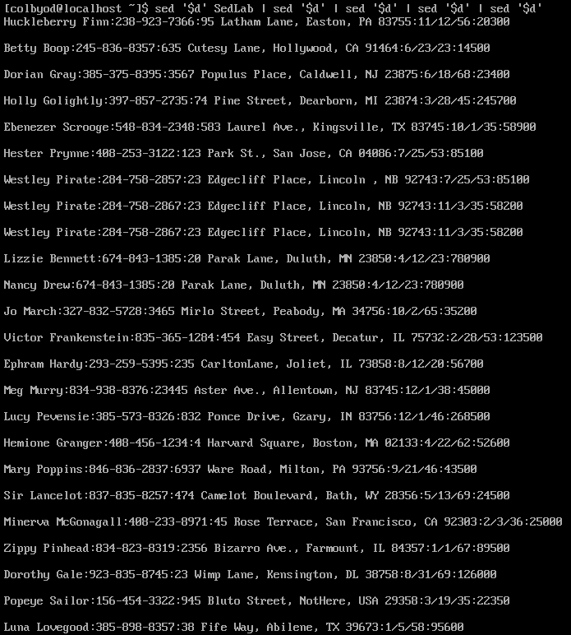

3. Print lines 3-15.

Using the **-n** option, we print lines 3-15 using the search of ‘3,15p’. The reason why it appears only 7 rows print out is that sed is also printing out the blank rows included in the file.



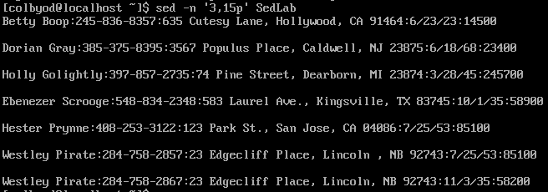

4. Delete lines for people who live in California

Here we use sed to search specifically for any rows including the string “CA” then use the command **d** to delete any line including that string.



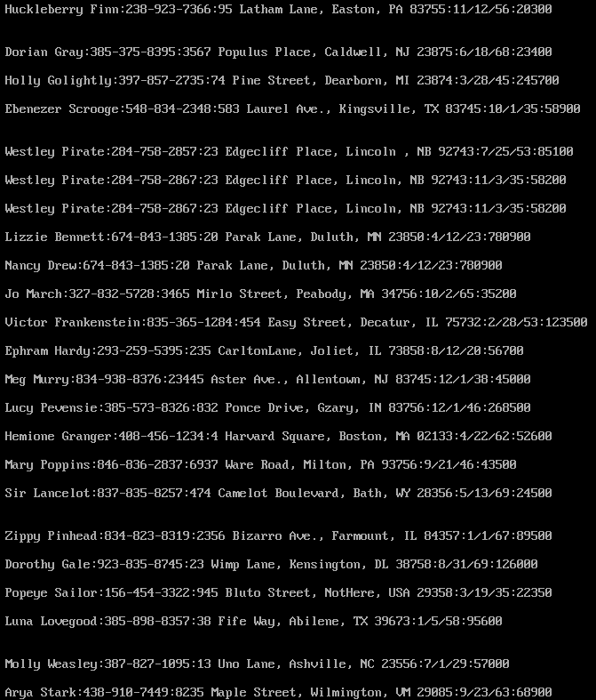

5. Print all lines where the birthdays are in the first week of the month. Be careful of the dates for birthdays, the format is MM/DD/YY



So I think I’m really close to getting this one but I can at least explain the thought process to the command I’ve come up with so far.

All it does is print out the entire file of **SedLab** unfortunately which is obviously not what I want to happen but the thought behind it is to match any line that has a string that begins with a number between 00 and 99 essentially. This is a bit of overkill and can be lessened to something more simple like **[0-1][0-2]** which would match with any number between 0 and 12. (I’m pretty sure) Each backslash ( **\** ) in the command is to include the next character in the search which follows our format of MM/DD/YY. The **0[1-7]** is to search for the next part of the string being **01-07** indicating the (DD) of the first week of each month (MM/DD). It is to then find a matching string between 00-99 which covers an entire century’s worth of years. The command is to then print **p** anything that matches to the text file **SedLab**.

6. Append three asterisks (*) to the end of lines starting with Sir

We first search for any lines in the file that begin with “Sir” and then using the “$” we skip to the end of any of those lines then append “***” to it.





7. Replace the line containing ”Westley Pirate” with the phrase ”As you wish.” Make sure you replace the whole line not just the name

Also using hours of StackOverflow we search for any line beginning (**^**) with “Westley Pirate” and then using **c** (change) that entire line to “As you wish.”



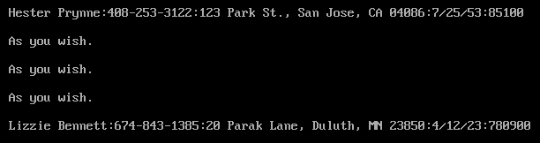

8. Change Minerva McGonagall’s birthday to 10/04/1935. Assume you don’t know Minerva’s original birthday. Use a regular expression to search for it.



Again I think I’m close but I’ll try to explain what I’m going for here. I’ve altered this thing a billion ways so I may be further away than I think but the thought is to match any line beginning **^** with **Minerva McGonagall**. It is to then find any string that follows the **MM/DD/YY** format but since we don’t know it we are searching for **00-99/00-99/00-99** and capture it using the surrounding **“\(“** and **“\)”**. The ensuing **/10\/04\/35/** is to changed the matched and captured string to **10/04/35.** Then of course print **p** the substitution **s/**.

9. Delete all blank lines.

We search for any line beginning (**^**) with a space, indicated by [[:space:]] then using **d** we delete that line from the file.



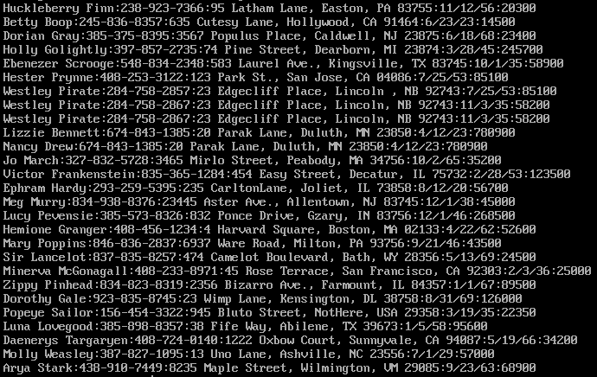

10. Write a sed script that will (actual sed script, NOT just the commands on the command line) (a) Insert above the first line the title - Great Literary Characters -.

(b) Print the contents of the file, but instead of the phone number starting with an area code, have it start with a 1+, then include the area code and number. For example, (603)123-1234 would turn into 1+(603)123-1234

(c) Append at the end of the file ”Happily Ever after. The End”

I got **a** and **c** to work appropriately but **b** is giving me a hard time. When I try to figure it out my VM starts to bug out.

